**Name of Title:** Learning Nginx

**Video Name:** Troubleshooting Nginx

**Estimated Length:**

**Author Name:** Michael Jenkins

**Chapter_Section_Video:**

**Video Objective:**

At the end of this video the learner will learn how to troubleshoot common problems with setting up sites like checking logs, printing and checking the config with `nginx -T `, and a few more.

**Introductory Statement:**

Type your introductory statement here.

**Speaking Points:**

1. Point_1
2. Point_2
3. Point_3
4. Point_4
5. Reference Pitfalls and Common Mistakes page in Nginx.com wiki

**Script:**

TITLE SLIDE:

As you’re working with Nginx, there may come a time where things just aren’t working the way you think they should.

Here are a few tools and ideas you can use to troubleshoot and resolve some of the typical problems you might encounter.

SLIDE: Test the Configuration

nginx -t

nginx: [emerg] unknown directive "servver" in /etc/nginx/conf.d/wisdompetmed.local.conf:1

nginx: configuration file /etc/nginx/nginx.conf test failed

We can catch configuration errors with nginx -t after making changes. If there’s a typo in your configuration file, nginx -t will identify the error and the file it occurs in, along with the line number. In this example, I’ve misspelled the server keyword on line one of the configuration file. This is an easy fix.

SLIDE: Test the Configuration

root /var/www/htm1

server_name example.com www.example**s**.com

Also check for typos in your root and server name directives. In some cases, typos won’t be flagged when you test the configuration. In this example, htm1 should really be html and [www.examples.com](http://www.examples.com) should be [www.example.com](http://www.example.com). Keep an eye out for elusive errors like

these.

But what about problems after you know the configuration is good?

SLIDE: Site Can’t Be Reached

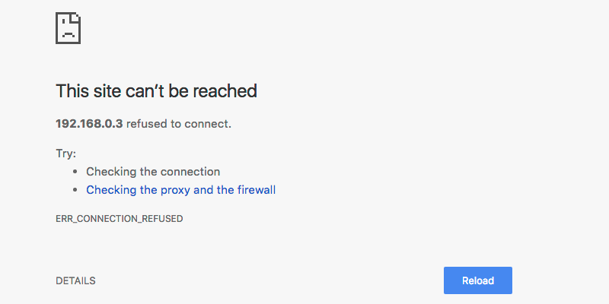

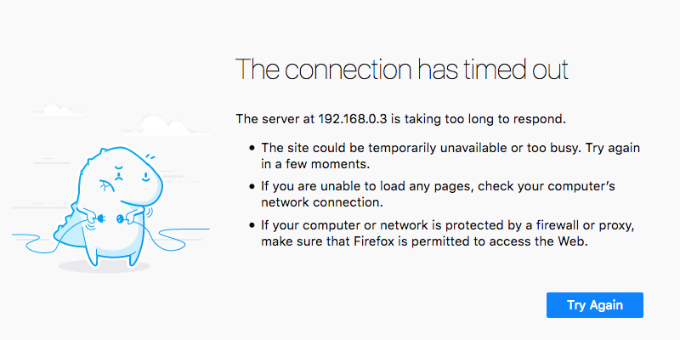

Let’s say for instance you’ve made some changes to your site but the changes aren’t showing up or you can’t reach your site at all.

(COULD BE DONE IN TERMINAL)

SLIDE: Check Nginx Status and Reload the Configuration

**sudo systemctl status nginx**

* nginx.service - A high performance web server and a reverse proxy server

Loaded: loaded (/lib/systemd/system/nginx.service; enabled; vendor preset: enabled)

Active: **active (running)** since Mon 2018-06-11 23:22:22 UTC; 14min ago

systemctl reload nginx

The first thing you can do is make sure nginx is running! The systemctl status nginx command gives output that confirms whether nginx is running or not.

Then you might also want to reload the configuration with systemctl reload nginx. This command does not produce any output if it runs successfully. So check the site afterward to see if your changes are now being applied.

(COULD BE DONE IN TERMINAL)

SLIDE: Make Sure Nginx is Listening on the Correct Ports

sudo lsof -i :80 -i :443

nginx 20802 root 6u IPv4 50685 0t0 TCP *:80 (LISTEN)

nginx 20903 www-data 6u IPv4 50685 0t0 TCP *:80 (LISTEN)

sudo netstat -plan | grep nginx

tcp 0 0 0.0.0.0:80 0.0.0.0:* LISTEN 20802/nginx: master

unix 3 [ ] STREAM CONNECTED 51645 20802/nginx: master

unix 3 [ ] STREAM CONNECTED 51644 20802/nginx: master

If nginx is up and running but you aren’t seeing anything served, you’ll want to check that the standard ports for HTTP and HTTPS traffic are open: ports 80 and 443.

You can check for status on these ports using the lsof and netstat commands. LSOF which is short of list open files, lists all the files and network ports that are open on the system. Using some the dash i switch, we can check to see if nginx is listening on ports 80 and 443.

Another way to confirm that nginx is listening on these ports, is with the network status, or netstat command. Netstat gives us information on all of the network connections for the system. Using the right switches --- dash P L A N -- and grepping for nginx, we can also get netstat to give us the ID of the process that’s listening to the port.

SLIDE: Tail the Logs

tail -f /var/logs/nginx/*.log

ADD SOME LOG OUTPUT HERE ( OR A SCREEN SHOT )

If your configuration is good and nginx is up, running, and listening on the right ports, but something is still out of place: its time to turn to the logs. You can use the tail command with the dash F switch to follow the nginx logs as they are being written to disk. While following the log, you can try to access various parts of your site and see if the accesses are being recorded. If they are, you can check for 400 errors which might lead to problems like files not being in the right place or directories that don’t have the correct permissions.

SLIDE: Seek Help

Search Engines

Stack overflow

If all else fails, seek help. You can turn to a search engine or stackoverflow.com to research the error or problem that you are seeing. Hopefully, someone else has encountered the same problem and provided a solution.

Finding solutions to your problems might take awhile at first, but As you gain more experience with nginx, your troubleshooting will become much more efficient.

**Needs wrap.**

**Conclusion:**

Type your conclusion statement here.

**Script and Media:**

Break the script up into parts and align it with any media (slides, web, CLI, etc.)

| **Part** | **Script** | **Media** |
| --- | --- | --- |
|  |  |  |

**Exercise Files:**

https://www.nginx.com/resources/wiki/start/topics/tutorials/config_pitfalls/

error_log /var/log/nginx/debug.log debug;

**Basement:**